# Sorting Rows by Family Members

This document includes the question, the solution, and a breakdown of the code provided in the screenshot.

## Uploaded Screenshot

Below is the screenshot of the task:

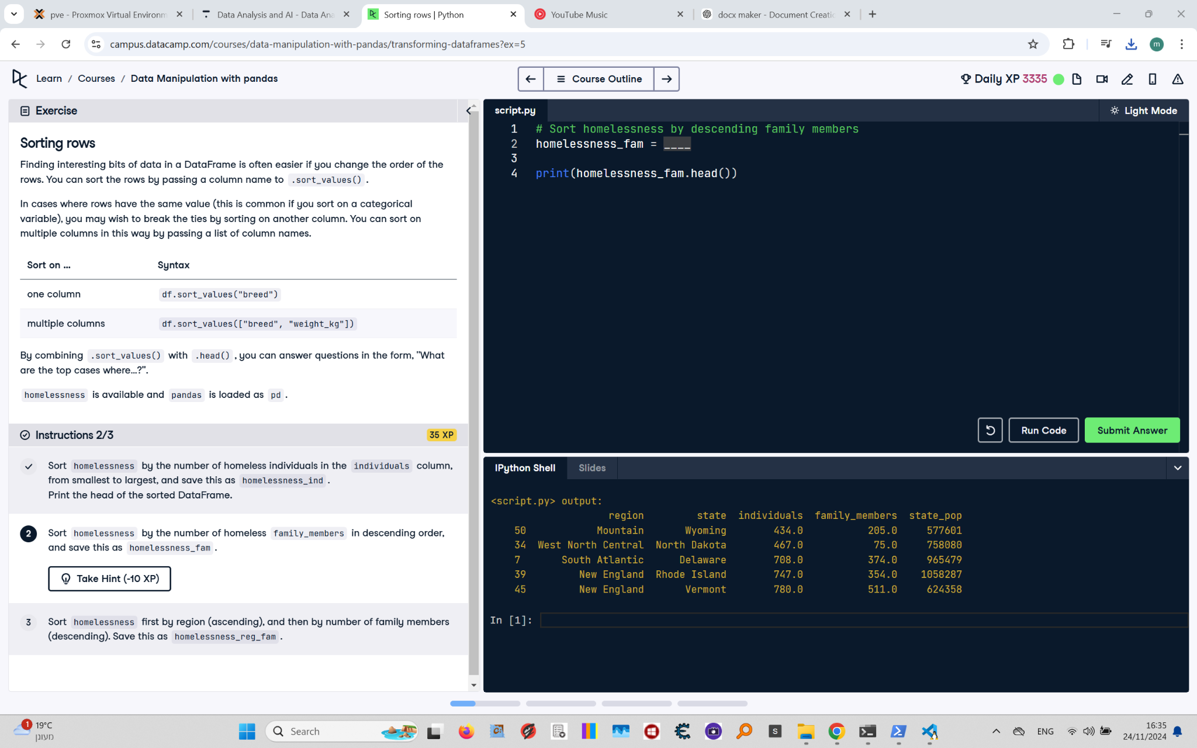

## Question

Sort the homelessness DataFrame by the number of family members in descending order, and save this as `homelessness_fam`. Print the head of the sorted DataFrame.

## Answer

# Sort homelessness by descending family members  
homelessness_fam = homelessness.sort_values("family_members", ascending=False)  
  
# Print the top few rows  
print(homelessness_fam.head())

## Code Explanation

# Explanation of the code:

1. `homelessness.sort_values("family_members", ascending=False)`: Sorts the `homelessness` DataFrame by the `family_members` column in descending order (from largest to smallest).

2. `homelessness_fam`: Stores the sorted DataFrame for further use.

3. `print(homelessness_fam.head())`: Displays the first five rows of the sorted DataFrame to verify the sorting.